1-Create a user account with the following attribute:

* username: islam
* Fullname/comment: Islam Askar
* A screenshot of a computer program

  Description automatically generatedPassword: islam

2- Create a user account with the following attribute:

* Username: baduser
* Full name/comment: Bad User
* 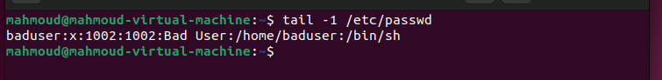A screenshot of a computer screen

  Description automatically generatedPassword: baduser

3- Create a supplementary (Secondary) group called pgroup with group ID of 30000

`-g` option to determine the group id

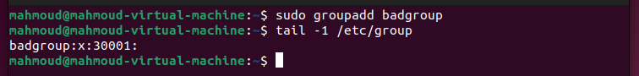4- Create a supplementary group called badgroup

5- Add islam user to the pgroup group as a supplementary group

`-aG` option to add ‘pgroup’ to islam’s groups without deleting the other secondary groups if exists

6- Modify the password of islam's account to password

7- Modify islam's account so the password expires after 30 days

8- Lock bad user account so he can't log in

9- Delete bad user account

10- Delete the supplementary group called badgroup.